Experience
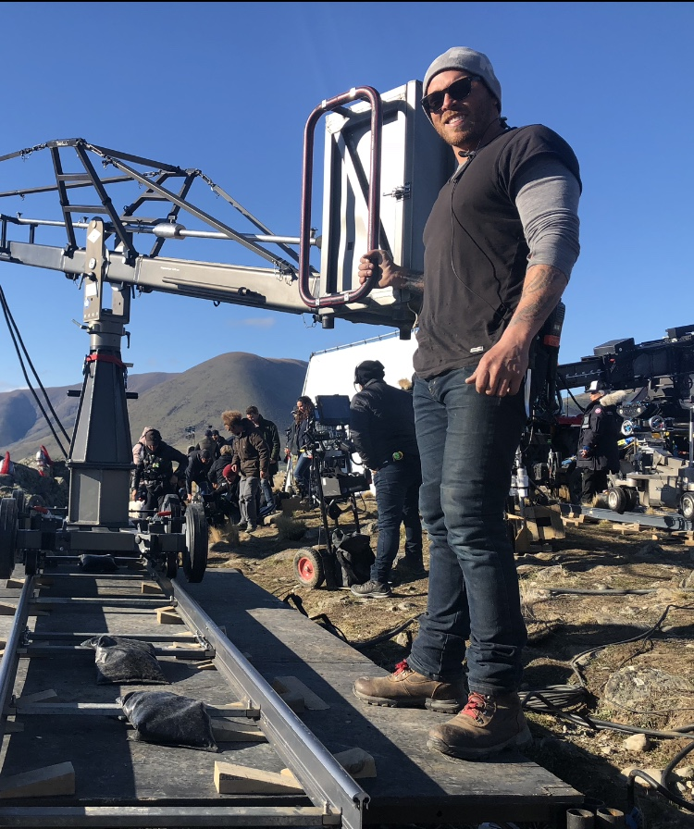

Corey Moana
  - keygrip at Gripping services NewZealand LTD.

  - Moana Grips LTD.
  - Email- Coreymoanagrips@gmail.com
  - Contact- +642108562834
  - kia ora,
  - i’M an ambitous key Grip with a drive to Accomplish the needs and meet budgets of every production.
  - i CONTINUE TO LOVE working WITHIn the film industry and find myself very fortunate to Have worked in many countires alongside different cultures and varying systems.
  - The Grip Crew that make up my department is that of the highest quality and experience.
  - I am a clear communicator, listener And take pride in leading a TEAM THAT IS HARDWORKING, EFFICIENT, CALM AND there to assist aLL departmentS WHILST MAINTAINinG SAFETY throughout a shoot.
- 17 year’s experience in international/Local film and TV.
- Roles include Dolly grip, Crane Grip, rigging, Onset/Offset Best boy and key grip.
- Experience in Helicopter slinging and loading.
- Experience in underwater Filming.
- Experience in multitude of shooting locations from open ocean to snow.
- Created strong networks within the industry and worked alongside filmmaker’s like James Cameron, Bob Richardson, Mandy walker, Don Burgess, Tom stern, Aaron Morton and more.
- Access to high quality equipment including Camera cranes, Chapman hybrid dollies, sliders, rigging equipment, Tracking vehicles and remote heads.

2023-2024 | -Chief of War: Key Grip 2U  DOP Josh Bliebtreu, Michael Snyman, Mathew Chuang  -Aqua man 2 Additional Photography: Key Grip  DOP Don Burgess
2022-2023 | -Choose Love: Key Grip  DOP Toby Oliver  -Our Flag Means Death Season 2: Key grip  DOP Mike Berlucchi, Nathaniel Goodman, Andy Rydzewski
2021-2022 | -Lord of the Rings: Key Grip  DOP Aaron Morton, Alex Disenhof  -Cowboy Beebop: Key Grip  DOP Thomas Burstyn, Dave Perkal
2020-2021 | -The Avatar Sequels: Key Grip 2U  DOP Richard Bluck  -Cowboy Beebop: Key Grip  DOP Thomas Burstyn, Dave Perkal
2019-2020 | -Fantasy Island: Key Grip  DOP Toby Oliver  The Avatar Sequels- Best Boy
2018-2019 | Mulan- Best Boy  Wrecked- B Dolly Grip
2017-2018 | Adrift – Best boy  Dynasty Warriors- A Dolly Grip  Mission Impossible Fallout- Company Grip
2016-2017 | Meg- B dolly Grip  Shanara Chronicles S2- B Dolly Grip
2015-2016 | Marco Polo S2-B Dolly Grip
2014-2015 | The Shanara Chronicles S1-B Dolly Grip
2013-2014 | Marco Polo S1- B Dolly Grip
2012-2013 | Ghost in the Shell- Production Rigging
2009-2012 | The Hobbit LOTR- Company Grip
2008-2009 | Power Rangers- Company Grip  Go Girls S2- Company Grip
2006-2008 | Short film, Tele Features, Commercials, NZ productions
2006-2024 | Variety of International commercials, Films, TV and Music videos
LICENCES
- Tracks and rollers
- Class 2&4 Truck  - Forklift  -Basic Scaffolding | - Gantry Crane  - Boom Lift  - Scissor Lift
- COC Scuba For underwater filming - Firearms
- Working at heights - Harness
- First aid

