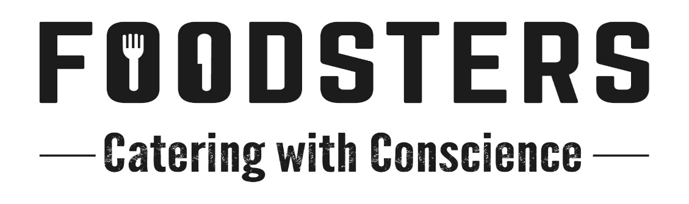
Started by Jono Clarke and Andy Meyers (both ex. Luscious Catering) in 2017, Foodsters is well known for providing the best, freshest, healthiest and most modern options of catering to your cast, crew, clients and agency.
The motto we have, Catering with Conscience, lets you know that we take pride in ensuring that we are as kind to our planet as we are to our clients. Our chicken, eggs, bacon, lamb and beef are always free range and where possible, our pork is too. As well as that, our packaging and disposables are all compostable or recyclable. All of our organic waste is collected for composting and we have a minimal waste policy in place at our kitchen.
Our kitchen is conveniently located next to the motorway on Dominion Rd in Mt Roskill, making those breakfast pickups a cinch.
We can provide a solution to any budget you have, including fully cooked and served breakfasts and lunches, to gourmet individual lunchboxes, handheld breakfasts and delicious afternoon teas.
Give us a call for your next shoot, we’re positive you will not be disappointed.
Andy 0225175132
Jono 0223649167
