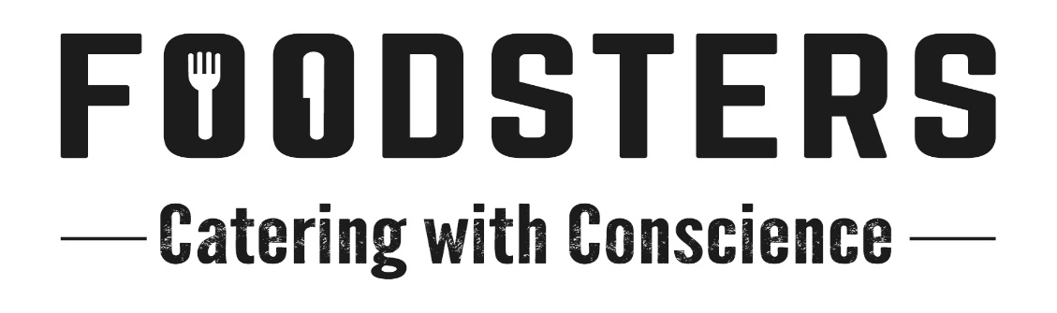
Sample Menus
Menus are samples only. Menus chosen for your catering will reflect fresh seasonal availability of ingredients.

Day 1:
Bacon, Egg, Spinach and Cheese Wraps (Mushroom for Vegetarians), Mueslis and Porridge

Chicken Larb (Fried Tofu with Lemongrass for Vege Option)
Steamed Jasmin Rice
Fresh Green Beans, Stir-fried with Toasted Coconut and Chilli
Vegetarian Spring Rolls
Vietnamese Rice Noodle Salad with Green Papaya and Fresh Herbs
Green Salad with Mung and Fresh Coriander

Coconut Panna Cotta with Melon Salsa and a Lime Leaf Dusting

Day 2:
Chorizo, Egg & Onion Jam Bagels, Mueslis and Porridge

Seared and Roasted Lamb Rump
Silverbeet and Barberry Bulgur Pilaf
Spinach and Ricotta Filo Pie
Harissa and Maple Roasted Carrot Salad with Whipped Goat’s Cheese
Kohl Rabi, Olive and Lemon Slaw
Mixed Leaf Salad with Cherry Tomatoes

Lime, Crème Fraiche & Pistachio Trifle

Day 3:
Fresh Filled Ham, Cheese and Tomato Croissant (Avocado for Vege), Mueslis and Porridge

Beef Osso Bucco in Rich Jus with Gremolata
Creamy Mashed Potatoes
Fresh Grilled Asparagus with Shaved Parmesan
Roasted Beetroots with a Fresh Chive & Preserved Lemon Labneh
Pea, Halloumi and Avocado Salad
Caramelised Onion, Fig and Feta Salad

Homemade Tiramisu Cups

