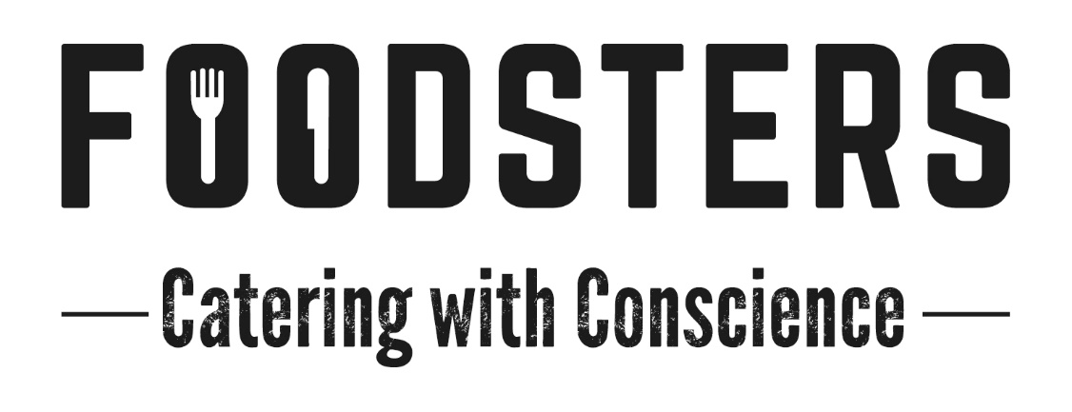
Rates
Handheld Breakfast: $8.50
Includes a combination of hot filled breads such as wraps, bagels etc. muesli with coconut yoghurt, porridge and/or omelettes. Always includes vegan and gluten free options when required.
Lunchboxes: from $15.50
Individual lunchboxes containing a meat or vegetarian protein, and a medley of modern gourmet salads.
Add Warm savoury and/or Sweet Slice @ $4ea
Served Banquet Lunches:
Option 1: $29 Hot meat or fish dish, hot vegetarian/vegan dish and four delectable sides complimenting the meal and the season. Fresh Artisan bread.
Option 2: $36 Two hot meat or seafood dishes, hot vegetarian/vegan dish and four delectable sides complimenting the meal and the season. Fresh Artisan bread.
Add Dessert: $4 A beautiful finish to the meal to put a smile on the crews faces. Always includes a vegan and gluten free option.
Morning and Afternoon Teas: $6
Freshly made with a different selection daily. Always includes Gluten Free and Vegan Options when required
Hearty Afternoon Tea options starting from $10

Please use these prices and choices as a guide only. We are more then happy to discuss with you any other options that you may need.
All prices exclusive of GST

