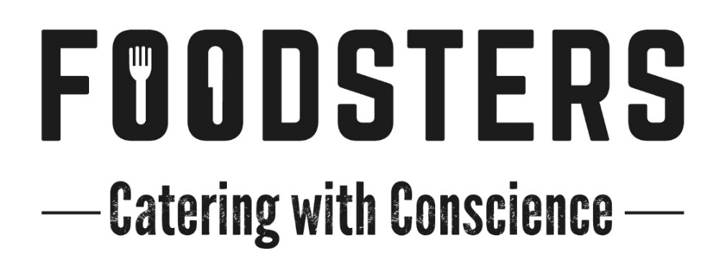
Rates
These rates are for short term bookings. Special rates can be discussed for longer running drama or feature film shoots
Handheld Breakfast: $10.00
Includes a combination of hot filled breads such as wraps, bagels etc. muesli with coconut yoghurt, porridge and/or omelettes. Always includes vegan and gluten free options when required.
Lunchboxes: from $22.50
Individual lunchboxes containing a meat or vegetarian protein, and a medley of modern gourmet salads.
Add Warm savoury and/or Sweet Slice @ $5ea
Hot Individual Lunchboxes: from $27.00
Individual lunchboxes containing a meat or vegetarian protein and hot starch, and a separate box of modern gourmet salads.
Served Banquet Lunches:
Option 1: $35 Hot meat or fish dish, hot vegetarian/vegan dish and four delectable sides complimenting the meal and the season. Fresh Dessert.
Option 2: $42 Two hot meat or seafood dishes, hot vegetarian/vegan dish and four delectable sides complimenting the meal and the season. Fresh Dessert.
Morning and Afternoon Teas: From $7
Freshly made with a different selection daily. Always includes Gluten Free and Vegan Options when required
Hearty Afternoon Tea options starting from $12
Please use these prices and choices as a guide only. We are more than happy to discuss with you any other options that you may need.
All prices exclusive of GST

